West Cumbrians’ VOICE for Health Care
Important changes are now being planned for the future of our local health and care services. If these changes are to give us something good and lasting the people of West Cumbria must be able to play a part in shaping them.
The launch of the Success Regime in June 2015 gave some hope that radical new solutions will be found to our long-standing problems. West, North and East Cumbria was one of only three areas in the country selected for Success Regime support because of its history of difficulties in recruiting permanent medical staff, financial problems and a need to improve services.
In the early days of the Success Regime there was concern that the people who would be most affected, the people who live here, were not being involved in the discussions and decision making and so, in September 2015, a group of people formed the West Cumbrians VOICE for Health Care to push for better community involvement, a joined-up health and care system and access to emergency and other services in good time, wherever we live.
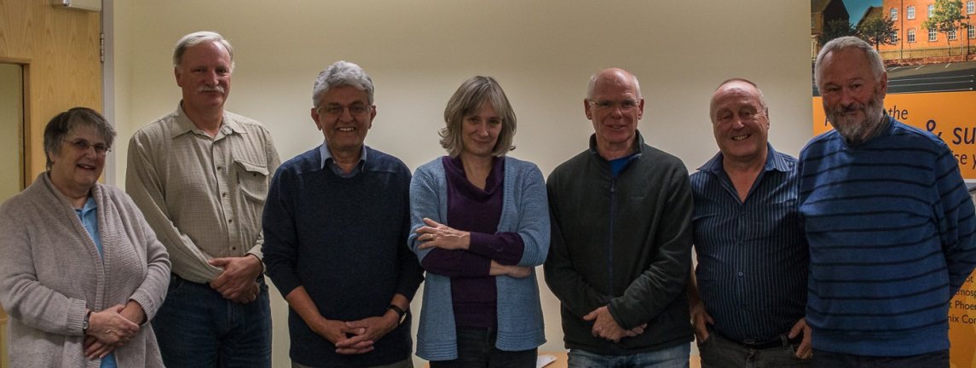
Founding members of West Cumbrian’s VOICE for Health Care
Dr Barrie Walker, retired Seascale GP and member of VOICE, has written a discussion paper explaining how the community could be served by a single organisation - GPs, community care organisations, the ambulance service, hospitals and specialist care - all working together to give us high quality care as close to home as possible.
The Save West Cumberland Hospital campaign has been very successful in raising awareness and gathering people’s experiences. We aim to add to this by using the many decades of experience in health and community service which some of our members have. We’ve worked hard to understand the issues and see the possibilities, meeting regularly with people from the NHS and other health and community organisations. We’ve tried to ask the hard questions. Above all, we have pressed for the people of West Cumbria to be involved.
If you want to know more about VOICE or to get in touch with us please go to our website http://www.cumbriansvoiceforhealth.com
Jan den Bak and Carole Woodman
Chair and Secretary
West Cumbrians’ VOICE for Health Care

