West Cumbrians VOICE for Healthcare
Why VOICE started  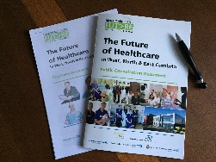  In 2015 the new NHS Success Regime announced a public consultation on plans which could slash maternity and other services at West Cumberland Hospital  Fear and anger in the community led to the formation of a vibrant campaign group, We Need West Cumberland Hospital. It arranged public meetings and protests and had a Facebook page with more than 16,000 members  We supported their cause and felt it could be helped by a group which would meet with NHS managers, challenge in detail the plans being made and work towards finding ways forward. West Cumbrians’ VOICE for Healthcare was set up in the autumn of 2015 | What we do  We meet NHS staff at all levels, analyse data and present reports, for instance on the impact of travelling long distances to give birth and a detailed response to the public consultation on The Future of Healthcare in West, North & East Cumbria  We now take part in the West Cumbria Community Forum and all aspects of the local NHS Co-production process*. This brings together patients, community members and NHS staff to help shape our current and future services  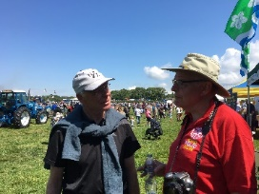  We support better disease prevention, currently helping to raise awareness of stroke prevention in the West Cumbrian community | Our aims and hopes for the future  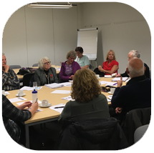  We want more people, especially those with experience of being patients, family members and carers, to share their experiences and knowledge with the health and care services here  You can become part of a local NHS co-production group on such matters as services for children, maternity services, telemedicine, care at a istance  We want the community to play a strong role in shaping services now and into the future. We welcome you to join us in VOICE and/or as colleagues in the local NHS co-production process. For more information see: http://www.northcumbriahealthandcare.nhs.uk/making-it-happen/co-production/

Website: https://www.cumbriansvoiceforhealth.com/

