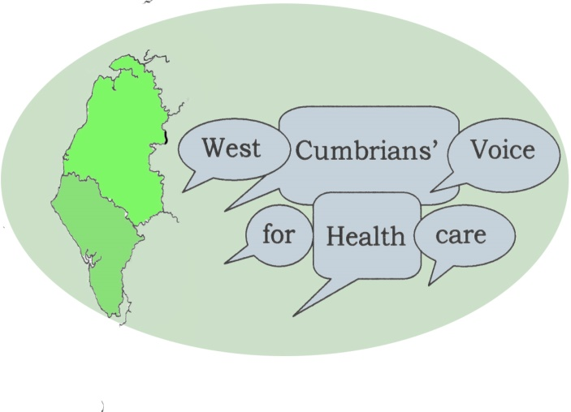
Sir Neil McKay,
Chair,
West, North and East Cumbria Success Regime

8 March 2016

Dear Neil,
The West Cumbrians’ Voice for Health Care welcomes the opportunity presented by the recent progress report of the West, North and East Cumbria Success Regime. The emerging options outlined in the report gives a foundation for individuals and community representatives to understand, discuss and debate the important decisions now being made for the future of health and care in Cumbria.
It is good to know that the options are still emerging, rather than already decided, and the report contains some good and non-controversial ideas. It also, from a West Cumbria point of view, contains some areas of real concern.
The West Cumbrians’ Voice for Health Care welcomes:
- The commitment to integrated care (ICCs) and a better use of community hospitals.
- The proposed clinical taskforce for urgent care, emergency care and acute medicine.
- The proposed increased elective surgery at WCH and the return of some acute surgery and trauma as was mentioned during the Forum meeting.
- The proposed arrangements with the Newcastle Trust for cancer care, children services and major trauma.
- The development of a new Workforce Strategy.
- The possible development of an Accountable Care system.
- The decentralisation of outpatient clinics, improving care pathways and the use of tele-medicine.

We have deep reservations about some suggestions and some questions to raise on them:
- The establishment of a single Acute Stroke Unit in Carlisle appears to be a fait accompli and not an emerging option allowing public participation. We would like to challenge this decision. Especially we would like to see clear evidence that people who suffer a stroke in West Cumbria are not disadvantage by this decision. And if this is indeed the case we would call for an equally firm commitment to the establishment of the recovery and rehabilitation phase of patients with a stroke at the WCH.
- We are disappointed with what seems to be an underlying message in the report on Woman and Children Services. Although four options would appear to be open, the reality seems to be that options 1 and 2 are already ruled out because of the reasons stated - no paediatric cover, uncertainty of other clinical services and financial issues. There is genuine fear that outcomes for children, young people and their families will suffer if there is not a fully functioning children’s ward at WCH with overnight stay longer than 24 hours. We believe a more positive approach can be taken to alternative possibilities, e.g. using the clinical taskforce here.
- A 24/7 A&E service is envisaged but there are no details on what the service would entail.
- The few lines on Mental Health are disappointing as this remains a major issue in the whole of Cumbria.
- The continuation of links (and strengthening through a legal binding agreement) with Northumbria remains contentious. Whatever ‘good’ they may have done for the Cumbria acute health system they certainly are also at least part responsible for the deficit, the fact that the NCUHT is in special measures and the downgrading of the services at WCH. We hope to hear that other arrangements will be looked at. The Partnership Trust (not mentioned once in the report!) and Newcastle spring to mind.
- We are also unsure about the idea of Helimedicine. Without more details and costings it is difficult to see how this will contribute to better, cost effective and sustainable services. Also there are no details as yet on ‘the reinforcement of the current transport capacity’. If services change dramatically a robust transport system is a must.

As a group we are committed to play a positive part in the public engagement and consultation on health and care here. We have let it be known that we are disappointed at the level of involvement by patients and the community up to now. All NHS guidance on effective engagement states that the public must be involved in developing the solutions together in a transparent, inclusive and accountable way. While we would like to understand the data and guidelines behind the emerging options we hope that this process does not just deal with the cold statistics and figures but also takes note and account of individual outcomes, quality and experience of care.

In our discussion paper the West Cumbrians’ Voice for Health Care clearly state that we have to look for a radical new system of health and social care for the whole of Cumbria. We find some snippets of this in the report. This is encouraging and hopefully will be a start of things to come. We do know that this will be a long haul of 5-10 years. We hope that no short term irreversible decisions will be made that jeopardise more equitable and equal services and equality of care for the people of West Cumbria.
With kind regards,

Jan den Bak
Chair
West Cumbrians’ Voice for Health Care
http://www.cumbriansvoiceforhealth.com

